User report
Perfect Charging

Fronius Perfect Charging optimises battery charging technology at Wallner

Reliable and efficient energy supply

(Wels, April 2023) Electronically operated heavy-duty forklifts with powerful traction batteries are indispensable for handling goods in the timber industry. Austrian timber merchant Wallner relies on the Selectiva 4.0 product range from Fronius Perfect Charging for it’s charging technology. For good reason: all batteries are always fully charged at the beginning of the shift and the energy consumption has even decreased.

The 60,000m2 premises of Wallner Holzhandel GmbH in St. Pölten are located next to a forest with an impressive tree population. For more than 80 years, the family business founded by Mr. Wallner has been dealing with the versatile and natural material of wood. In addition to the wholesale of timber, Wallner also operates a modern cutting and edging centre for individual customer requirements.

More than 80 employees ensure that the timber products reach the customer in the desired form on time. In order to load and unload the heavy and bulky panels of wood onto the company’s own fleet of trucks, a large number of electronically operated heavy-duty forklifts are used. The intralogistics are coordinated by the warehouse manager at the location, Herbert Baumgartner. "We are currently operating 11 sideloader trucks, which were specially manufactured according to our requirements. Many years ago the fleet was changed to electric drive and is now powered by large lead-acid batteries."

Time for a new charging solution
For charging these traction batteries, the company relied on a 50 Hz technology in the past. The chargers regularly caused high power peaks and an overload of the company network. A disruption of the charging process often led to downtimes of the forklift trucks as no exchangeable batteries are used due to the single-shift operation. A problem that presented a major challenge for the timber trading company, where smooth operations are essential.
With the expansion of the site and the planning of a new warehouse, also the charging infrastructure was completely renewed. Baumgartner had no doubt that Fronius was the right partner for the job: “I already knew the high-quality chargers from Fronius from the automotive sector and was therefore very interested in their solutions for intralogistics.”

In close collaboration with the customer the Fronius Perfect Charging team developed the ideal charging concept. Individually designed charging stations were planned, to suit the special requirements and dimensions of the heavy-duty forklifts. High reliability and particularly efficient and gentle charging of the powerful traction batteries were also a priority.

Reduced load peaks and deep discharge characteristics
The charging concept sustainably reduces peak loads, which previously led to high costs. Thanks to the unique Ri charging process and the possibility to delay the start of charging by half an hour, no more power peaks occur at Wallner. Failures in the company network are also a thing of the past.

The smart possibilities for optimisation, the local contact person and the peace-of-mind Fronius quality have convinced the customer all along the line: "Since we started using the Selectiva chargers, our batteries are always fully charged at the beginning of the shift. We have been able to reduce energy consumption by about 30%."

Mr Baumgartner is particularly impressed by the integrated deep discharge characteristic. Thanks to this, even a set of older lead-acid batteries could be regenerated and returned to its original use. "We had already depreciated the batteries in our minds, as charging with the old chargers was no longer possible. With the Selectiva deep discharge characteristic we were able to use the batteries for several more months - a sustainable and cost-efficient solution that helps us enormously as a family business."

3,921 characters incl. spaces

Captions

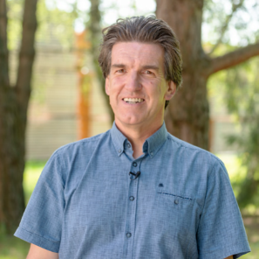
Herbert Baumgartner, warehouse manager at Wallner Holz: “Since we started using the Selectiva chargers, our batteries are always fully charged at the beginning of the shift. We have been able to reduce energy consumption by about 30%.”

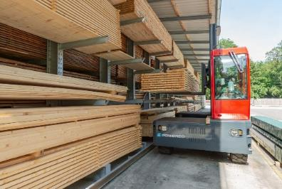
11 sideloader trucks where specially manufactured according to the requirements of the timber trading company.

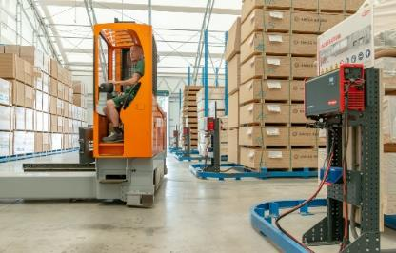
Many years ago Wallner changed the fleet to electric drive.

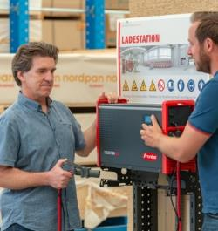
Mr Baumgartner is particularly impressed by the integrated deep discharge characteristic of the Selectiva chargers. Thanks to this, even a set of older lead-acid batteries could be regenerated and returned to its original use.

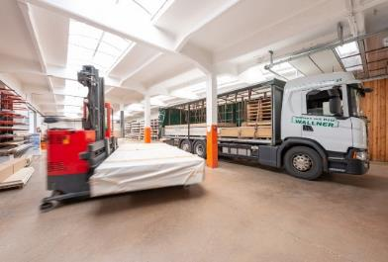
Wallner loads heavy and bulky panels of wood with the help of trucks and electronically operated heavy-duty forklifts.

Photo credits: Fronius International GmbH, reproduction free of charge

The high-resolution images are available for download here.

We are Fronius.
Over 7000 employees worldwide, a current export share of 89 percent, and 1366 active patents: that’s us, that’s Fronius. Founded in 1945 as a regional one-man operation, we are now a global player - a fact that is impressively demonstrated by our 37 international subsidiaries and our network of sales partners in more than 60 countries. And yet, at our core, we are still a family-owned company from Austria, active in photovoltaics, welding, and battery charging technology. We have always developed products and solutions for a future worth living, offering our customers an all-in-one package in the process: from advance planning and consulting to ongoing monitoring and a repair service tailored to their specific needs. We are innovative. We are curious. We are Fronius.

Contact details for this publication:

Company name: | Fronius Perfect Charging
E-Mail: | perfect.charging@fronius.com
Website: | www.fronius.com/intralogistik
YouTube: | www.youtube.com/FroniusCharging
LinkedIn: | www.linkedin.com/showcase/perfect-charging
Phone UK & Ireland | +44 1908 512300

For further exciting updates, follow us on LinkedIn (perfect-charging) and YouTube (FroniusCharging)!

For more information, please contact:
Fronius UK Ltd, Maidstone Road, Kingston, Milton Keynes, MK10 0BD

Natalie Woodford, +44 (0)1908 512 300, Woodford.natalie@fronius.com

Please send a specimen copy to our agency:
a1kommunikation Schweizer GmbH,
Kirsten Ludwig, +49 (0)711 9454161-20, Kirsten.Ludwig@a1kommunikation.de
Oberdorfstraße 31 A, 70794 Filderstadt, Germany

